REGISTRATION
Name:
Address: _____________________________
Town/City:
Postal Code:
Phone #:
E-Mail:
Birth Date: (M) (D) (Y)
Health Card #
Contact Person:
Relationship:
(H) (W) (C)
Medical information or allergies:

Level played last year:
Novice Atom Peewee

Jersey Size:

Hockey School Payment:
$282.50

Payment by:
Cash/Debit
Visa/MasterCard/Amex/Discovery
Cheque

Please send your payment to:
Yarmouth Jr. A Hockey Ltd.
88 Forest St., Yarmouth, NS
B5A 4G6

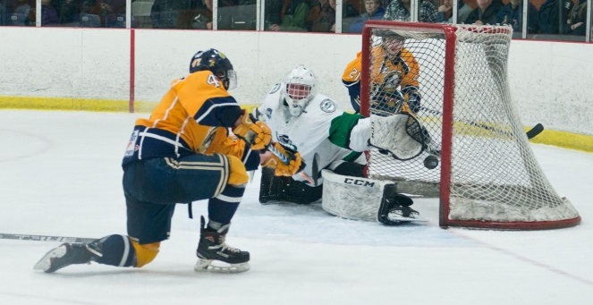

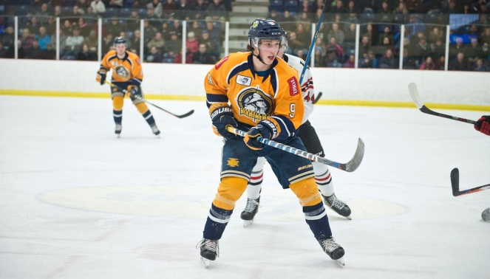

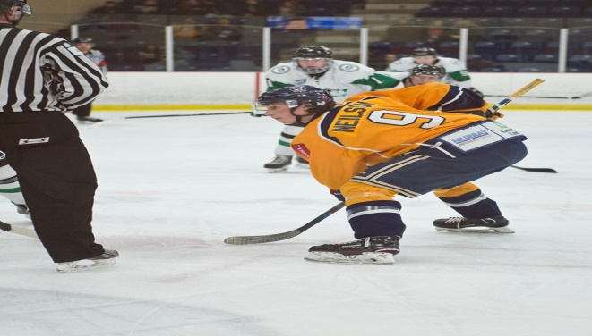

\

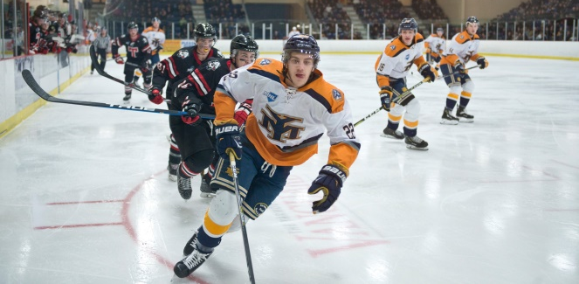

www.yarmouthmariners.com

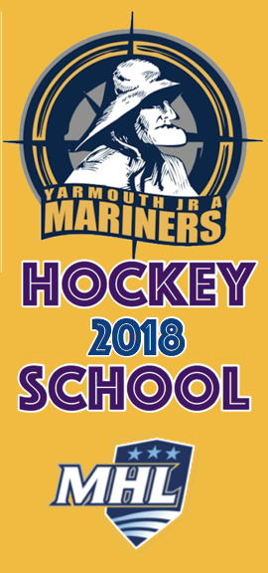

Train with the Mariners

www.yarmouthmariners.com

Hockey School
& Conditioning Camp

August 19 – 23, 2019

This is a full day camp. The primary focus of the camp is on individual skill development.

The camp will consist of three hours on ice per day as well as off-ice conditioning and video sessions.

Mariner’s staff and players oversee and run the camp. Players are fully supervised at all times.

Drop off is 8:15 to 8:45 AM - pick up at 4 PM

Lunch is not provided.

Novice, Atom and PeeWee age groups – great player to instructor ratio!

Focus Will Include:

- Puck Handling
- Power Skating
- Shooting
- Passing
- Over Speed
- Edge Work
- Conditioning
- Technique
- Off-Ice Puck Sessions

Hockey School Cost:

$282.50 HST incl.
Price includes Mariners Practice Jersey

www.yarmouthmariners.com

About our Instructors:

LAURIE BARRON

Laurie (LB) is back in for his 4th season as Head Coach and General Manager of the Yarmouth Jr. A Mariners after a brief hiatus when he coached the OHA in the United Kingdom and the South Shore Lumberjacks in 2015-16.

Laurie has a rich history in Hockey gathering many professional awards including:

MHL Coach of the Year 2017-2018
Yarmouth County Coach of the Year 2013
MHL Coach of the Year 2011-2012
Assistant Coach Team East Prospects
Assistant Coach Team East WJAC 2012
Selected Head Coach of Nova Scotia Under 17 hockey team
Selected Head Coach of Nova Scotia Under 16 hockey team
Junior Hockey Recognition Award from Hockey Canada
Five Provincial Titles, Three Don Johnson Cups
Three time Coach of the Year Nova Scotia Junior B Hockey League
Selected Head Coach of Nova Scotia Raiders Hockey Program
LB has 38 years’ experience in most levels of hockey and has a strong background in player development.

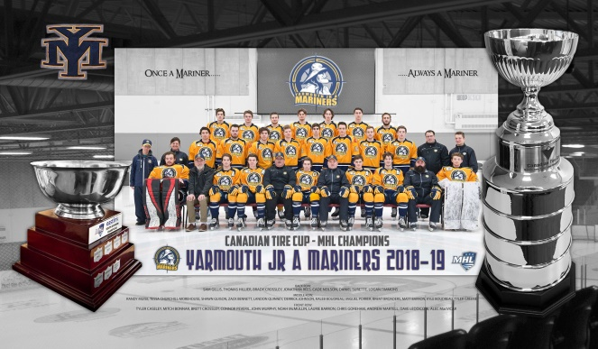

JOHN MURPHY

John is the assistant coach and the assistant GM of the Yarmouth Jr A Mariners.
John has lived the majority of his life in Yarmouth and brings a vast wealth of knowledge and skills to the development of youth hockey players in the area. John had coached minor hockey and high school hockey for 20 years in Yarmouth before joining the Mariners in 2010. He also spent time playing Jr. A with the Halifax Lions in 1986 and followed up playing Senior Hockey in Nova Scotia. John is responsible for coaching the Mariners defence corps and was integral in helping the team with the EastLink Division Championship. His desire and experience to help young hockey players in the Yarmouth area is second to none and he looks forward to continuing the development of young hockey players.

KYLE BOUDREAU

Kyle is returning assistant coach and goalie instructor.
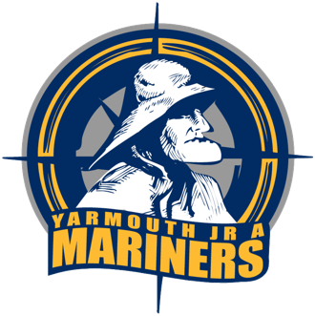

Yarmouth Jr. A Hockey Ltd.
88 Forest St., Yarmouth, NS
B5A 4G6
902 742 9254
info@tri-star.ca

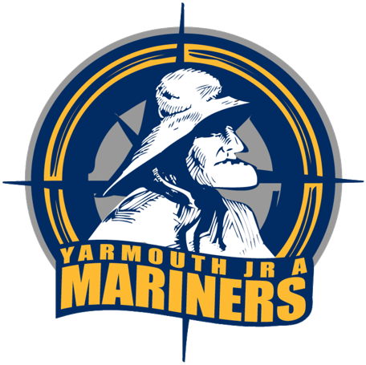
www.yarmouthmariners.com

